# | Item Name/ Description | Unit | Unit Price | Qty | Total Price | Manufacture / Origin
1 | Combo pH/Conductivity/TDS Tester (Low Range)  HI98129  The HI98129 makes measuring pH quick and easy! This lightweight, waterproof tester offers high accuracy pH, low range EC/TDS (0 to 3999 µS/cm EC/ 0 to 2000 ppm TDS) and temperature measurements in a single handheld unit! No more switching between meters for your routine measurements.  - Waterproof  - Replaceable pH electrode with extractable junction  - Automatic calibration  The HI98129 is a highly accurate, waterproof pH meter that can also measure EC/TDS in the low range (0 to 3999 µS/cm EC/ 0 to 2000 ppm TDS) and temperature. This floating, waterproof combination tester has an easy to read, LCD and an automatic shut-off. In addition, pH and EC/TDS readings are automatically temperature compensated (ATC) to prevent temperature-related variations in your measurements. For EC/TDS readings, the EC/TDS conversion factor (CONV) is selectable by the user, as well as the temperature compensation coefficient β (BETA).  Replaceable pH Electrode Cartridge  The HI98129 tester features an easy to replace pH electrode cartridge with an extendable cloth junction. The extendable cloth junction helps increase electrode life and the replaceable pH cartridge means that this tester does not need to be thrown away when the pH sensor is exhausted. Also, the sturdy, snap-in connector means there are no pins to bend or break!  High Accuracy EC/TDS Graphite Probe  The graphite conductivity probe provides greater accuracy because it cannot be contaminated by salt deposits in the solution. The exposed temperature sensor provides fast response times and guarantees highly accurate temperature compensated readings.  Features at-a-glance  - 3 sensors in a single meter  pH electrode with extractable junction  Amperometric EC/TDS sensor  Exposed temperature probe for faster EC/TDS readings  - Waterproof  Designed to float if accidently dropped in sample  - Wide pH Range  pH range is from 0.00 to 14.00 pH  - Selectable EC to TDS conversion factor  Choice of either a 0.45 or 1.0 conversion factor  - Automatic Temperature Compensation  All readings are compensated for variations in temperature  Temperature displayed in ºC or ºF along with pH, EC or TDS reading  - Stability indicator  Meter displays a clock tag that will disappear when the reading has achieved stability  - HOLD button  Freezes reading on the display to allow recording of measurement  - BEPS (Battery Error Prevention System  Meter will automatically shut off if there is not enough power to get an accurate measurement  - Battery % level at startup  - Low Battery Indicator  When the level is below 5%, the battery symbol on the LCD blinks to indicate a low battery condition.  - Auto-off  Auto-off feature automatically shuts off meter after 8 minutes of non-use to maximize battery life  Specifications: | Each | 195 | 4 | 780 | HANNA INSTRUMNETS/ USA, Europe
  pH Range | 0.00 to 14.00 pH
  pH Resolution | 0.01 pH
  pH Accuracy | ±0.05 pH
  pH Calibration | automatic, at one or two points with two sets of standard buffers (pH 4.01 / 7.01 / 10.01 or pH 4.01 / 6.86 / 9.18)
  pH Temperature Compensation | automatic
  EC Range | 0 to 3999 µS/cm
  EC Resolution | 1 µS/cm
  EC Accuracy | ±2% F.S.
  EC Calibration | automatic, one-point at: 1413 µS/cm
  TDS Range | 0 to 2000 ppm (mg/L)
  TDS Resolution | 1 ppm (mg/L)
  TDS Accuracy | ±2% F.S.
  TDS Calibration | automatic, one-point at: 1382 ppm (mg/L)
  EC/TDS Temperature Compensation | automatic with β adjustable from 0.0 to 2.4% / °C
  EC to TDS Conversion Factor | 0.45 to 1.00
  Temperature Range | 0.0 to 60.0°C / 32.0 to 140.0°F
  Temperature Resolution | 0.1°C / 0.1°F
  Temperature Accuracy | ±0.5°C /±1°F
  pH Electrode | HI73127 (replaceable; included)
  Battery Type/Life | 1.5V (4) / approx. 100 hours of continuous use, auto-off after 8 minutes of non-use
  Environment | 0 to 50°C (32 to 122°F); RH max 100%
  Dimensions | 163 x 40 x 26 mm (6.4 x 1.6 x 1.0’’)
  Weight | 100 g (3.5 oz.)
  Ordering Information | HI98129 is supplied with HI73127 pH electrode and HI73128 electrode removal tool, batteries (4 x 1.5V) and instructions.
5 | UV -Spectrophotometer  Cat3: UV-M51  Description:  Wavelenght range is from 190nm to 1000nm with Absorbance, Transmittance, Concentration and Factor measuring modes.  Bandwitdth 2nm.  The internal database can store 200 groups of data. Halogen and deuterium lamp can be turned on/off individually  to extend lifetime. The instrument is equipped with USB to be connected to a computer.  The UV-PROFESSIONAL software included expands the applications to:  Photometry, Quantitative analysis, Wavelenght scanning, Standard curve, Kinetics (time scanning), Multi-wavelenght analysis.  Also additional features like: spectrum computing (spectrum addition, subtraction, multiplication and spectrum division).  Spectrum derivative and spectrum compare. DNA/Protein Analysis  Included Accessories: Advanced Software for connection to computer, 2 quartz cuvette 10mm, 4 glass cuvette 10mm  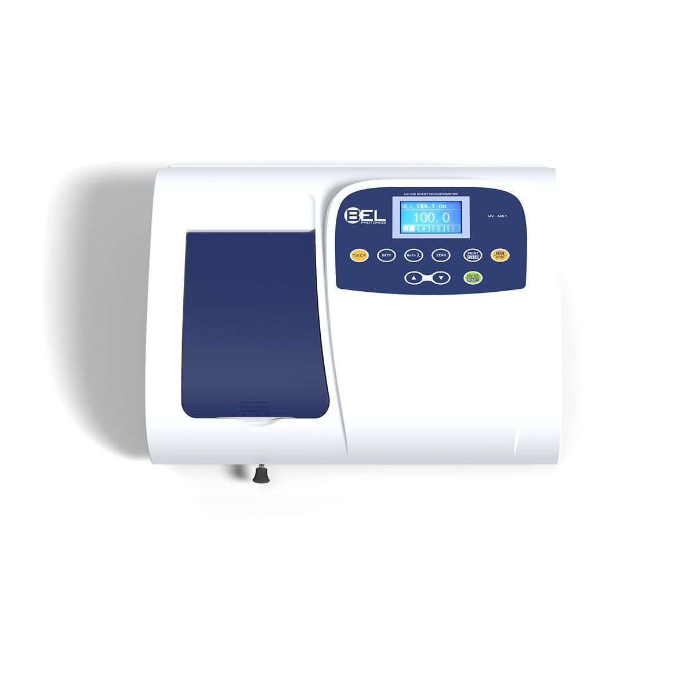 | Each | 1850 | 2 | 3700 | BEL Engineering/ Italy
  Optical system | Single beam with CT monochromator  1200 l/mm grating
  Wavelength Range | 190~1000nm
  Wavelength Setting | Auto
  Photometric Display Range | 0~200%T, -0.3~3.0A, 0~9999C
  Band Width | 2nm
  Scan Speed | 800nm/min
  Wavelength Accuracy | ±1nm
  Wavelength Repeatability | 0.5nm
  Photometric Accuracy | ±0.5%T
  Photometric Repeatability | 0.3%T
  Operating modes | T, A, C, F
  Stability | 0.002A/h @ 500nm
  Stray Light | ≤0.3%T
  Standard cell holder | 4-position 10mm cell holder
  Display | 128*64 Dots LCD
  Lamps | Deuterium Lamp & Halogen Lamp
  Detector | Silicon Photodiode
  Data Output Port | USB
  Printer port | Parallel
  Power Requirement | AC 110V-220V 80W
  Dimension (W*L*H), Weight | 420*280*180mm 15kg
 | فقط أربعة الاف واربعمائة وثمانون دينار لا غير | المجموع |  |  | 4480.000

- التسليم خلال : 30-90 days

